**Electrification of the transport System: Impacts of national policies vs external drivers. A case study for Pakistan.**

Molly Charles1, Zarrar Khan1, Sha Yu, Steve Smith, Juliet Homer, Travis Douville, Trevor Hardy, Others from USAID ?,

*1 Joint Global Change Research institute, Pacific Northwest National Laboratory (PNNL), College Park, MD 20740, USA*

*2 PNNL Richland*

*3 USAID*

**Abstract**

XXX.

Table of Contents

1. Introduction 3

1.1. Background 3

1.2. Literature Review 3

1.3. Research Question 3

2. Methodology 3

2.1. Cross-Model Links (GCAM, PLEXOS, SEP) 3

2.2. GCAM Overview 3

2.3. GCAM Transport Sector Details 3

2.4. GCAM Scenario Details 3

2.5. PLEXOS Overview 4

2.6. SEP Model Overview 4

3. Results 4

3.1. GCAM Baseline Results 4

3.2. GCAM Scenario Results – EV adoption, emissions impacts 4

3.3. PLEXOS Results – power demand, infrastructure needs 4

3.4. SEP Model Results – fuel needs by type, fuel costs 4

4. Discussion & Conclusions 4

References 4

Appendices 5

Appendix A Pakistan-specific changes to core GCAM 5

A.1 Socioeconomic assumptions 5

A.2 Power sector changes 5

A.1.1 Fossil Generation 5

A.1.2 Hydropower 6

A.1.3 Nuclear 6

A.2 Industry changes 6

A.3 Transportation changes 6

A.3.1 General updates to transportation assumptions 6

A.3.2 Pakistan-specific transportation changes 8

A.3.3 Battery cost curves update (1/16/20) 10

*A.3.3.2* *4W LDVs* 11

*A.3.3.3* *2-wheelers* 12

3-wheelers 12

*A.3.3.4* *Trucks* 12

*A.3.3.5* *Buses* 12

Appendix B EV analysis 12

B.1 Policy scenarios 13

B.2 Sensitivity analysis 15

# Introduction

# Background & Literature Review

The transport sector accounts for a fourth of global greenhouse gas (GHG) emissions, with road transport accounting for more than half of all transport-related emissions (Clarke et al. 2015; Edelenbosch et al. 2017). Private ownership of road vehicles is projected to increase with the increase in both population and income (McCollum et al. 2013; “Transport — IPCC” 2014). Switching to electric vehicles (EVs) has been proposed as a significant way to both lower energy consumption as a result of improved efficiencies as well as divert direct transport sector emissions to power generation. When coupled with appropriate power sector decarbonization efforts, the switch to EVs is an effective strategy to lower emissions (Zhang and Fujimori 2020; McCollum et al. 2013; Kyle and Kim 2011).

Costs of EVs are rapidly falling and several projections show cost parity with traditional internal combustion engine (ICE) vehicles as soon as 2025-2030 (Schmidt et al. 2017; Jadun et al. 2017; Richardson 2013). In the meantime, various regions are adopting a range of incentives to encourage faster adoption of EVs in their transport fleets along with support for required infrastructure and shifts in electricity demand profiles. These include measures such as subsidies for EV consumers, taxes on ICE vehicles, government procurement of electric vehicle fleets, building networks of charging stations, and reinforcing the electricity grid (Wappelhorst 2018; Yang 2016). Several cities (Paris, London, Los Angeles, Bangalore) have signed pledges with the intent to completely electrify their public bus fleets over the next few years (Parik 2016).

With the large uncertainty in cost projections and the range of policy measures to incentivize EV adoption, several studies have explored different transport system transformation pathways. McCollum et al. (2013) analyze several combinations of global technological advancements, availability of different fuels, and emissions targets and find that transport electrification frees up valuable resources such as biomass, diversifies the primary energy mix in transport and increases energy security. Other studies investigate EV pathways in a range of countries including Colombia (González Palencia, Furubayashi, and Nakata 2014), China (Hao, Wang, and Ouyang 2011), India (Mittal et al. 2017), across Europe (Mersky et al. 2016; Egnér and Trosvik 2018; Seixas et al. 2015; Hawkins et al. 2013), while others compare the impact of policies across different nations (Wu and Zhang 2017; Sierzchula et al. 2014). These studies in general find that while EV costs are dropping and widespread adoption can have numerous benefits, this still requires significant policy support and investment in technological advancement to make EVs a cost-effective mobility option for consumers (Seixas et al. 2015). While the high capital cost of EVs is a barrier to widespread adoption, measures such as fiscal incentives, public charging infrastructure, road priority, and public vehicle procurement can be effective policy levers to increase EV penetration (Wang, Tang, and Pan 2019; Egnér and Trosvik 2018; Mersky et al. 2016; Lévay, Drossinos, and Thiel 2017). Nonetheless, a range of additional measures including fuel economy, increase in mass transit, and low carbon fuel mix, will be needed for effective decarbonization of the transport sector (Mittal et al. 2017; Hao, Wang, and Ouyang 2011).

Developing countries are expected to see the largest growth in both population and incomes and a corresponding increase in road transport (“Transport — IPCC” 2014; Dargay, Gately, and Sommer 2007). Pakistan’s population is expected increase from 207.7 million in 2017 (Pakistan Bureau of Statistics, 2017 Census) to 279 million in 2050 (Pakistan Planning Commission), while per capita income is expected to grow from about $1300 in 2020 to $6500 in 2050 (Pakistan Planning Commission). Corresponding vehicle ownership is projected to increase by 26.3 million vehicles between 2021 and 2030 (SEP). Although Pakistan has developed significant local manufacturing of conventional ICE vehicles, there is currently no local production of electric vehicles (Pakistan Business Council 2018). Thus, in contrast to countries like China which have domestic EV production (Shiqi Ou et al. 2017), Pakistan is much more susceptible to EV technology costs and advancement pathways. This forces the government to take on a reactionary approach to the uncertain projections in order to achieve its EV penetration targets. In addition, Pakistan’s energy mix is projected to heavily expand coal (IGCEP 2019) which, when combined with transport sector electrification, could counteract desired decarbonization efforts (Zhang & Fujimori et al. 2020). This study expands on existing efforts and explores the effectiveness of a suite of policy measures to meet EV penetration goals and the corresponding emission impacts in a country like Pakistan, which is susceptible to international EV technology costs and advancement pathways combined with large uncertainty in projections of its future growth and energy mix.

# Research Question

This analysis aims to address several questions regarding Pakistan’s potential switch to electrified transport:

* What are the impacts of incentives on EV penetration?
* What is the sensitivity of EV adoption to technological and cost development?
* What are the impacts on power supply requirements and fuel consumption?
* What are the impacts on vehicular and power sector emissions?

# Methodology

# Cross-Model Links (GCAM, PLEXOS, SEP)

Several models are used in tandem for this analysis. GCAM is primarily used to develop EV adoption curves and resulting emissions impacts. The Sustainable Energy for Pakistan (SEP) Project team then uses the GCAM EV adoption curves in their EVM model to produce hourly EV load profile data, total annual EV GWh requirement, and EV-displaced vehicle fuels. These results are then provided to the National Transmission & Dispatch Company (NTDC), Pakistan’s national grid operator, who uses the adoption curves in the PLEXOS model to determine the capacity and generation mix to serve EV demand under the different scenarios. Though GCAM also models interactions with the power sector and fuel consumption, PLEXOS is a more detailed energy market model, and NTDC’s modeling is more directly tied to fuel mix and expansion plans for Pakistan’s power sector under NTDC’s Indicative Generation Capacity Expansion Plan. SEP then uses the PLEXOS results in their EVM model to analyze fuel requirements for additional power generation and associated fuel costs.

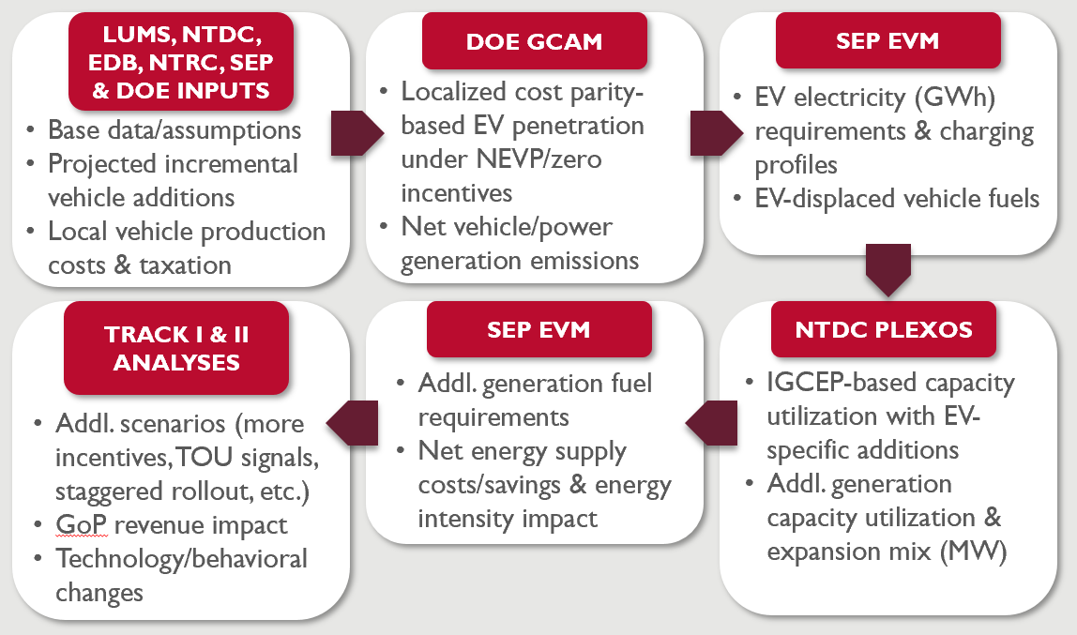

Source: Sustainable Energy for Pakistan (SEP) Project.

# GCAM Overview

Part of the analysis for this report was conducted using the Global Change Assessment Model (GCAM). GCAM is a global, multi-sector, market equilibrium model. It represents the behavior of and interactions between the global energy, water, agriculture and land use, economy, and climate systems. There are 32 geopolitical regions in GCAM, one of which is Pakistan. The model runs in 5-year time steps through the end of the century, with 2010 as the final calibration year. In each period, the model calculates equilibria across all global and regional markets.

# GCAM Transport Sector Details

GCAM has a high level of detail represented in the transportation sector. The sector is divided into four final demands: passenger, freight, international aviation, and international shipping. The demand for transportation services (in passenger-kilometers or ton-kilometers) in each region and time period is driven by GDP, population, cost of transport services, and income and price elasticities. The final demands are further broken down into different modes (e.g., road, rail), sub-modes (e.g., bus, light duty vehicle), size classes (e.g. compact car, moped), and technologies (e.g. liquids, hybrid liquids, battery electric). At the passenger subsector level, a time value, determined by the wage rate (per-capita GDP divided by the number of working hours in a year) and exogenously specified vehicle speed, is incorporated into the competition between transport modes. This causes a shift towards faster modes of transportation as incomes increase. Non-fuel costs, such as capital and maintenance costs, are exogenously specified for each transport technology. Fuel costs are endogenously calculated based on demand and regional supply curves. These costs are totaled and levelized to a single monetary cost per passenger-kilometer or ton-kilometer. The model then calculates market shares for each transport technology based on a logit choice specification, which avoids a “winner-take-all” result for the lowest cost option.[1] Some transportation vehicles are vintaged, with older vehicles retiring over time and new vehicles added in each future model year.

Transport service demands for each GCAM region are calibrated in the base year so that transportation energy consumption matches IEA energy balance data. IEA data provides total fuel consumption in the road transportation sector; detailed breakdowns beyond this level (e.g. between passenger and freight, modes, and size classes) are based on regional data and assumptions. The default assumptions and sources for the transportation module of GCAM are documented in Mishra et al. 2013. However, we update many assumptions to capture more recent data on EV technological development, as well as Pakistan-specific transport characteristics based on input from collaborators.[2] As non-fuel costs and other parameters such as intensity are exogenous, consumer choices do not influence the characteristics of the transport technologies themselves. For example, higher EV adoption rates would not result in faster technological improvement and cost reduction.

Transport technologies in GCAM each have a share weight value, which serves as a representation of consumer preferences in two ways: first, to calibrate the model to historical IEA energy balance data and absorb regionally specific preferences, and second, to allow new technologies to be phased in gradually. EV share weights for all vehicle types are calibrated to 0 in the base year and gradually increase to 1, on par with conventional liquids vehicles.

# GCAM Scenario Details

**Baseline Assumptions**

For this analysis, we focus on road transport and run the model up to 2050. Pakistan’s road technologies in GCAM include two-wheelers (mopeds, motorcycles, and scooters), three-wheelers, cars (mini cars, subcompact cars, compact cars, and multipurpose vehicles), buses, and trucks (0-2 tons, 2-5 tons, 5-9 tons, and 9-16 tons). All of these transport classes have both conventional liquids and BEV technologies represented. All except two-wheelers also have natural gas vehicles available, and cars additionally have hybrid liquids and fuel cell electric vehicle technologies. We use vehicle cost assumptions based on data from NREL (Jadun et al. 2017), but adjust them using data on battery costs from a review of the literature (see appendix A.3.2. for more details). Energy intensity comes from Jadun et al. 2017, and other assumptions such as load factor, annual distance traveled, and base-year energy use come from Mishra et al. 2013. When possible, we adjust assumptions to be Pakistan-specific (see appendix A.3.3).

**NEVP Overview**

The government of Pakistan (GoP) recently approved targets for EV penetration under the National Electric Vehicle Policy (NEVP). These are summarized in the table below:

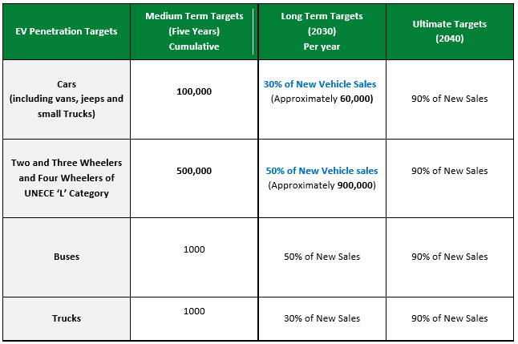

Policy objectives include reducing greenhouse gas emissions and air pollution, reducing the oil import bill, using electricity at off-peak times and reducing idle capacity payments, and supporting domestic manufacturing of electric vehicles. To increase EV adoption, the NEVP proposes numerous policy measures. These include sales tax exemptions for locally produced EVs, exemption from registration fees and annual token tax, lower duties for vehicle imports, reduced or eliminated duties for imports of EV-specific materials and parts used in local production, government procurement of electric bus and truck fleets, EV-specific zones in high density areas, and expansion of public charging infrastructure.

**NEVP Representation in GCAM**

For our baseline (no policy) scenarios, we assume no EV incentives. Pakistan’s vehicle taxes, import duties, and fees under the Automotive Development Policy 2016-21 apply equally to all vehicle technologies. We assume current levels of localization of ICEV production and no localization of EV production, in the absence of policies supporting this[3].

In our policy scenarios, we model only the monetary EV incentives, which affect vehicle cost inputs. We model the NEVP tax, duty, and fee incentives under no localization of EV production, gradual localization, and accelerated localization, as incentives vary for local versus imported vehicles and materials and have a significant effect on the results. We run the policy scenarios on top of slow and rapid EV technology advancement scenarios to provide a range of possible cost pathways, as future technology and cost development remains quite uncertain.

# PLEXOS Overview

# SEP Model Overview

# Results

# GCAM Baseline Results

GCAM projects transport service output to grow significantly in Pakistan over time frame considered in this study. Passenger service output is projected to grow by 130% from 2020 to 2050, while freight service output triples. Within passenger transport, the largest share, about 70%, of service demand is met by buses. Modal shift is observed over time, as demand shifts to faster modes along with increasing per-capita GDP. The share of passenger service provided by cars increases from 10% to 23% between 2020 and 2050, while the share provided by two-wheelers decreases from 9% to 3%. The share of walking and cycling similarly decreases from 8% to 1% of passenger transport, while the share of demand met by buses remains relatively constant over this time period. Within freight transport, most service demand (about 97%) is met by trucks rather than freight rail, predominantly by the larger truck classes (5-9 tons and 9-16 tons).

In the absence of policies to reduce the cost of EVs, there is limited EV market penetration for most vehicle classes, with high sensitivity to the technology advancement pathway. The exception is two-and three-wheelers, which reach cost parity with their ICEV counterparts by 2020 (see appendix A.3.3.); EV penetration is about 10% in 2020 and continues increasing through 2050 as costs drop, to about 25% of new sales in 2050 under slow technology advancement and 45% in 2050 under rapid technology advancement. Electric cars and buses have much lower adoption in the no policy scenarios. The EV share in new car sales ranges from 4% (slow advancement) to 12% (rapid advancement) in 2050. However, certain size classes reach cost parity sooner, such as compact cars, and have higher penetration as a result[4]. Electric buses have somewhat higher EV penetration than cars, increasing to 9% of new sales in under slow advancement and 32% under rapid advancement in 2050, as the lower operating costs of EVs provide a larger benefit for high-mileage vehicles. For freight trucks, there is especially high uncertainty regarding future technology advancement, resulting in a wide range of potential costs. Once BEV capital costs drop enough, high truck intensities give BEVs a large fuel cost advantage. Under slow advancement, the share of electric trucks in new sales is nearly zero through 2050, while it reaches 18% by 2050 under rapid advancement. In both no policy scenarios oil products remain the dominant transport fuel source through 2050, with natural gas making up the next largest share (15-20%). Under rapid technology advancement, electricity makes up 7% of fuel consumption by 2050, while the share is nearly zero under slow advancement.

# GCAM Scenario Results – EV adoption, emissions impacts

The EV policy and cost scenarios result in a wide range of adoption. EV penetration also differs greatly by vehicle class, as the smaller EVs reach cost parity with their ICEV counterparts much sooner than larger vehicles, and the NEVP is more effective in incentivizing EV purchase for vehicles where EV and ICEV costs are closer to parity. For all vehicle classes, the share of EVs in new sales decreases after the NEVP benefits phase out in 2030. However, this may not be realistic; a limitation of GCAM is that it does not capture feedbacks to vehicle costs or adoption rates, such as economies of scale, learning-by-doing, or shifts in consumer preferences due to increased familiarity with EVs. It is possible that policies to support EV purchase and manufacturing would have longer-lasting impacts than those shown in the model results.

For electric two- and three-wheelers, which are already cost competitive with ICEVs, the NEVP incentives are effective in increasing penetration by making EVs cheaper than their ICEV equivalents. Between 2020 and 2030, after which the policy phases out, the NEVP benefits increase the EV share in new sales by 10 to 30 percentage points; when combined with higher localization, the effect is even larger. The share of EVs in new sales ranges from 21% in 2030 in the lowest case (slow technology development, no policy, and no EV localization) to 76% in 2030 in the high case (rapid technology development and NEVP with accelerated localization). Service output of two- and three-wheelers decreases over time, as service output shifts to faster modes with growth in per-capita GDP. However, faster EV cost improvement and NEVP incentives both increase two- and three-wheeler usage in the near term.

For cars, the NEVP with no localization increases EV penetration by about 9 percentage points under slow advancement and 15 percentage points under rapid advancement. Accelerated localization, which further decreases duties, increases penetration in 2030 by an additional 15-20 percentage points under both cost scenarios. The EV share of new sales in 2030 ranges from 4% under slow advancement, no policy to 46% under rapid advancement and NEVP with accelerated localization.

Buses and trucks see a smaller bump in EV penetration as a result of the NEVP, since EVs are relatively more expensive than their ICEV counterparts and adoption is low between 2020 and 2030. In addition, the NEVP only affects capital costs, and operating costs, including fuel and maintenance, are larger share of total levelized costs compared to smaller vehicles. NEVP incentives along with accelerated localization increase EV bus penetration by 3-4 percentage points under slow advancement and 8-9 percentage points under rapid advancement. For trucks, the NEVP has no effect on EV penetration under slow advancement, as it cannot make up for the large difference in costs between EVs and ICEVs. Under rapid advancement, NEVP incentives plus localization increase EV penetration by 3-7 percentage points relative to no policy.

In GCAM, the transport sector makes up about 20% of Pakistan’s CO2 emissions. Compared to the no policy cases, NEVP incentives with accelerated localization can reduce transport sector CO2 emissions by 3-4% per year under slow advancement and 6-7% per year under rapid advancement. Transport electrification also has a slight net negative effect on total CO2 emissions, though it causes electricity sector emissions to increase. Power sector emissions are sensitive to the fuel mix, which was adjusted to better reflect Pakistan’s generation projections from the IGCEP (see appendix A.2). Because of this, coal-fired generation increases significantly over time, limiting the effectiveness of EV policies in cutting CO2 emissions. Run low-carbon fuel mix scenario?

Non-CO2 emissions

# PLEXOS Results – power demand, infrastructure needs

# SEP Model Results – fuel needs by type, fuel costs

# Discussion & Conclusions

1. Summary of results
2. Implications for other regions
3. Local policies versus external forces

# References

“Battery Pack Prices Fall As Market Ramps Up With Market Average At $156/KWh In 2019.” 2019. BloombergNEF. December 3, 2019. https://about.bnef.com/blog/battery-pack-prices-fall-as-market-ramps-up-with-market-average-at-156-kwh-in-2019/.

Berckmans, Gert, Maarten Messagie, Jelle Smekens, Noshin Omar, Lieselot Vanhaverbeke, and Joeri Van Mierlo. 2017. “Cost Projection of State of the Art Lithium-Ion Batteries for Electric Vehicles Up to 2030.” *Energies* 10 (9): 1314. https://doi.org/10.3390/en10091314.

“BYD K9.” 2020. In *Wikipedia*. https://en.wikipedia.org/w/index.php?title=BYD_K9&oldid=941473263.

Clarke, Leon E., Kejun Jiang, Keigo Akimoto, Mustafa Babiker, Geoffrey J. Blanford, Karen Fisher-Vanden, Jean-Claude Hourcade, Volker Krey, Elmar Kriegler, and Andreas Loschel. 2015. “Assessing Transformation Pathways. In: Climate Change 2014: Mitigation of Climate Change. Contribution of Working Group III to the Fifth Assessment Report of the Intergovernmental Panel on Climate Change.” Pacific Northwest National Lab.(PNNL), Richland, WA (United States).

Dargay, Joyce, Dermot Gately, and Martin Sommer. 2007. “Vehicle Ownership and Income Growth, Worldwide: 1960-2030.” *The Energy Journal* 28 (4). https://doi.org/10.5547/ISSN0195-6574-EJ-Vol28-No4-7.

Edelenbosch, O. Y., D. L. McCollum, D. P. van Vuuren, C. Bertram, S. Carrara, H. Daly, S. Fujimori, et al. 2017. “Decomposing Passenger Transport Futures: Comparing Results of Global Integrated Assessment Models.” *Transportation Research Part D: Transport and Environment* 55 (August): 281–93. https://doi.org/10.1016/j.trd.2016.07.003.

Egnér, Filippa, and Lina Trosvik. 2018. “Electric Vehicle Adoption in Sweden and the Impact of Local Policy Instruments.” *Energy Policy* 121 (October): 584–96. https://doi.org/10.1016/j.enpol.2018.06.040.

Gallagher, Kelly Sims, and Erich Muehlegger. 2011. “Giving Green to Get Green? Incentives and Consumer Adoption of Hybrid Vehicle Technology.” *Journal of Environmental Economics and Management* 61 (1): 1–15. https://doi.org/10.1016/j.jeem.2010.05.004.

González Palencia, Juan C., Takaaki Furubayashi, and Toshihiko Nakata. 2014. “Techno-Economic Assessment of Lightweight and Zero Emission Vehicles Deployment in the Passenger Car Fleet of Developing Countries.” *Applied Energy* 123 (June): 129–42. https://doi.org/10.1016/j.apenergy.2014.02.059.

Hao, Han, Hewu Wang, and Minggao Ouyang. 2011. “Fuel Conservation and GHG (Greenhouse Gas) Emissions Mitigation Scenarios for China’s Passenger Vehicle Fleet.” *Energy* 36 (11): 6520–28. https://doi.org/10.1016/j.energy.2011.09.014.

Hawkins, Troy R., Bhawna Singh, Guillaume Majeau‐Bettez, and Anders Hammer Strømman. 2013. “Comparative Environmental Life Cycle Assessment of Conventional and Electric Vehicles.” *Journal of Industrial Ecology* 17 (1): 53–64. https://doi.org/10.1111/j.1530-9290.2012.00532.x.

Holland, Maximilian. 2018. “$100/KWh Tesla Battery Cells This Year, $100/KWh Tesla Battery Packs In 2020.” CleanTechnica. June 9, 2018. https://cleantechnica.com/2018/06/09/100-kwh-tesla-battery-cells-this-year-100-kwh-tesla-battery-packs-in-2020/.

Jadun, Paige, Colin McMillan, Daniel Steinberg, Matteo Muratori, Laura Vimmerstedt, and Trieu Mai. 2017. “Electrification Futures Study: End-Use Electric Technology Cost and Performance Projections through 2050,” 108.

Kittner, Noah, Felix Lill, and Daniel M. Kammen. 2017. “Energy Storage Deployment and Innovation for the Clean Energy Transition.” *Nature Energy* 2 (9): 1–6. https://doi.org/10.1038/nenergy.2017.125.

Kyle, Page, and Son H. Kim. 2011. “Long-Term Implications of Alternative Light-Duty Vehicle Technologies for Global Greenhouse Gas Emissions and Primary Energy Demands.” *Energy Policy* 39 (5): 3012–24. https://doi.org/10.1016/j.enpol.2011.03.016.

Lee, Henry, and Grant Lovellette. 2011. “Will Electric Cars Transform the U.S. Market?” *SSRN Electronic Journal*. https://doi.org/10.2139/ssrn.1927351.

Lévay, Petra Zsuzsa, Yannis Drossinos, and Christian Thiel. 2017. “The Effect of Fiscal Incentives on Market Penetration of Electric Vehicles: A Pairwise Comparison of Total Cost of Ownership.” *Energy Policy* 105 (June): 524–33. https://doi.org/10.1016/j.enpol.2017.02.054.

McCollum, David, Volker Krey, Peter Kolp, Yu Nagai, and Keywan Riahi. 2013. “Transport Electrification: A Key Element for Energy System Transformation and Climate Stabilization.” *Climatic Change* 123 (3–4): 651–64. https://doi.org/10.1007/s10584-013-0969-z.

Mersky, Avi Chaim, Frances Sprei, Constantine Samaras, and Zhen (Sean) Qian. 2016. “Effectiveness of Incentives on Electric Vehicle Adoption in Norway.” *Transportation Research Part D: Transport and Environment* 46 (July): 56–68. https://doi.org/10.1016/j.trd.2016.03.011.

Mittal, Shivika, Hancheng Dai, Shinichiro Fujimori, Tatsuya Hanaoka, and Runsen Zhang. 2017. “Key Factors Influencing the Global Passenger Transport Dynamics Using the AIM/Transport Model.” *Transportation Research Part D: Transport and Environment* 55 (August): 373–88. https://doi.org/10.1016/j.trd.2016.10.006.

Moawad, Ayman, Namdoo Kim, Neeraj Shidore, and Aymeric Rousseau. 2016. “Assessment of Vehicle Sizing, Energy Consumption and Cost Through Large Scale Simulation of Advanced Vehicle Technologies.” ANL/ESD--15/28, 1245199. https://doi.org/10.2172/1245199.

Nykvist, Björn, and Måns Nilsson. 2015. “Rapidly Falling Costs of Battery Packs for Electric Vehicles.” *Nature Climate Change* 5 (4): 329–32. https://doi.org/10.1038/nclimate2564.

Ou, Shiqi, Zhenhong Lin, Zhixin Wu, Jihu Zheng, Renzhi Lyu, Steven V. Przesmitzki, and Xin He. 2017. “A Study of China s Explosive Growth in the Plug-in Electric Vehicle Market.” ORNL/TM--2016/750, 1341568. https://doi.org/10.2172/1341568.

Parik, Gunjan. 2016. “C40: Cities Are Leading An Electric Bus Revolution.” C40. September 9, 2016. https://www.c40.org/blog_posts/cities-are-leading-an-electric-bus-revolution.

Poon, Linda. 2019. “The Electric Bus Is Running Late.” CityLab. July 20, 2019. https://www.citylab.com/transportation/2019/06/electric-bus-china-grid-ev-charging-infrastructure-battery/591655/.

“Proterra: US Record for Electric Bus Battery Capacity - Sustainable Bus.” 2019. March 23, 2019. https://www.sustainable-bus.com/news/proterra-set-a-new-us-record-for-electric-bus-battery-capacity/.

Richardson, David B. 2013. “Electric Vehicles and the Electric Grid: A Review of Modeling Approaches, Impacts, and Renewable Energy Integration.” *Renewable and Sustainable Energy Reviews* 19 (March): 247–54. https://doi.org/10.1016/j.rser.2012.11.042.

Schmidt, O., A. Hawkes, A. Gambhir, and I. Staffell. 2017. “The Future Cost of Electrical Energy Storage Based on Experience Rates.” *Nature Energy* 2 (8): 17110. https://doi.org/10.1038/nenergy.2017.110.

Seixas, J., S. Simões, L. Dias, A. Kanudia, P. Fortes, and M. Gargiulo. 2015. “Assessing the Cost-Effectiveness of Electric Vehicles in European Countries Using Integrated Modeling.” *Energy Policy* 80 (May): 165–76. https://doi.org/10.1016/j.enpol.2015.01.032.

Sierzchula, William, Sjoerd Bakker, Kees Maat, and Bert van Wee. 2014. “The Influence of Financial Incentives and Other Socio-Economic Factors on Electric Vehicle Adoption.” *Energy Policy* 68 (May): 183–94. https://doi.org/10.1016/j.enpol.2014.01.043.

Stromsta, Karl-Erik. 2019. “Proterra Rolls Out $200 Million Electric Bus Battery Leasing Program With Mitsui.” April 16, 2019. https://www.greentechmedia.com/articles/read/proterra-rolls-out-bus-battery-leasing-program-with-mitsui.

“Transport — IPCC.” 2014. 2014. https://www.ipcc.ch/report/ar5/wg3/transport/.

Wang, Ning, Linhao Tang, and Huizhong Pan. 2019. “A Global Comparison and Assessment of Incentive Policy on Electric Vehicle Promotion.” *Sustainable Cities and Society* 44 (January): 597–603. https://doi.org/10.1016/j.scs.2018.10.024.

Wappelhorst, Sandra. 2018. “Using Vehicle Taxation Policy to Lower Transport Emissions: An Overview for Passenger Cars in Europe,” December, 54.

Wu, Ya, and Li Zhang. 2017. “Can the Development of Electric Vehicles Reduce the Emission of Air Pollutants and Greenhouse Gases in Developing Countries?” *Transportation Research Part D: Transport and Environment* 51 (March): 129–45. https://doi.org/10.1016/j.trd.2016.12.007.

Yang, Zifei. 2016. “Principles for Effective Electric Vehicle Incentive Design,” June, 43.

Zhang, Runsen, and Shinichiro Fujimori. 2020. “The Role of Transport Electrification in Global Climate Change Mitigation Scenarios.” *Environmental Research Letters* 15 (3): 034019. https://doi.org/10.1088/1748-9326/ab6658.

# Appendices

# Pakistan-specific changes to core GCAM

## Socioeconomic assumptions

We began by adjusting GCAM’s default projections for Pakistan to better align with projections made by stakeholders within Pakistan. We used Shared Socioeconomic Pathway (SSP) 5 assumptions for population and GDP growth rather than the default of SSP 2, as these aligned better with data from the Pakistan Planning Commission. GDP growth rate assumptions were also updated to reflect the latest IMF data on GDP growth rates.[5]

## Power sector changes

Default GCAM power sector projections for Pakistan were adjusted based on the 2019 Indicative Generation Capacity Expansion Plan (IGCEP) 2018-40. This report gives an overview of Pakistan’s existing power system, forecasts future electricity demand, and presents the results of expansion planning studies conducted by the Load Forecast and Generation Planning (LF&GP) of Power System Planning (PSP), National Transmission and Dispatch Company (NTDC). In addition, we use updated capital costs for intermittent and dispatchable renewable technologies, which come from NREL’s Annual Technology Baseline 2018 edition.

### Fossil Generation

As the IGCEP does not include plans to expand generation from refined liquids, we set the refined liquids share weight in electricity generation to 0 after 2020. We also increase coal share weights to reflect plans in the IGCEP to expand coal-fired power generation. However, we do not fully match IGCEP in this case because of feedback that the government of Pakistan aims to revise the coal generation plan from IGCEP downward in the next version.

Refined liquids share weights

|  |  |  |  |  |  |  |  |  |  |
| --- | --- | --- | --- | --- | --- | --- | --- | --- | --- |
|  | **2010** | **2015** | **2020** | **2025** | **2030** | **2035** | **2040** | **2045** | **2050** |
| **Default** | 1 | 0.95556 | 0.911111 | 0.866667 | 0.822222 | 0.777778 | 0.733333 | 0.688889 | 0.644444 |
| **Adjusted** | 1 | 0 | 0 | 0 | 0 | 0 | 0 | 0 | 0 |

Coal share weights

|  |  |  |  |  |  |  |  |  |  |
| --- | --- | --- | --- | --- | --- | --- | --- | --- | --- |
|  | **2010** | **2015** | **2020** | **2025** | **2030** | **2035** | **2040** | **2045** | **2050** |
| **Default** | 0.00081317 | 0.00856 | 0.010038 | 0.01179 | 0.013864 | 0.016317 | 0.019215 | 0.022637 | 0.026672 |
| **Adjusted** | 0.00081317 | 0.250407 | 0.15 | 0.25 | 0.5 | 0.7 | 0.8 | 0.7 | 0.6 |

### Hydropower

Hydropower electric generation in GCAM is given as fixed output. We base hydro generation for 2020-2040 on the hydro generation projections given in the IGCEP. From 2040-2050, we assume constant linear increase in hydro generation at the 2020-2040 average rate. We hold hydro generation constant beyond 2050, as the analysis for this project only goes through 2050.

Pakistan hydro generation (EJ):

|  |  |  |  |  |  |  |  |  |
| --- | --- | --- | --- | --- | --- | --- | --- | --- |
|  | **2015** | **2020** | **2025** | **2030** | **2035** | **2040** | **2045** | **2050** |
| **Default** | 0.117706 | 0.120892 | 0.124078 | 0.127264 | 0.13045 | 0.140089 | 0.149728 | 0.159367 |
| **Adjusted** | 0.117706 | 0.143935 | 0.238579 | 0.422274 | 0.530093 | 0.573574 | 0.66302 | 0.749482 |

### Nuclear

Share weights for nuclear technologies were increased between 2015 and 2050 to align nuclear generation in GCAM with IGCEP plans. For 2020-35, we calculated generation based on capacities of IGCEP committed nuclear plants, assuming a capacity factor of 0.8.[6] We then iterated on the nuclear share weights to get generation close to the IGCEP projections.

|  |  |  |  |  |  |  |  |  |  |
| --- | --- | --- | --- | --- | --- | --- | --- | --- | --- |
|  | **2010** | **2015** | **2020** | **2025** | **2030** | **2035** | **2040** | **2045** | **2050** |
| **Default** | 0.024771 | 0.05 | 0.05 | 0.058333 | 0.066667 | 0.075 | 0.083333 | 0.091667 | 0.1 |
| **Adjusted** | 0.024771 | 0.05 | 0.5 | 1 | 1 | 1 | 0.1 | 0.1 | 0.1 |

## Industry changes

After making these adjustments to the power sector, electricity generation was significantly higher in GCAM in early years compared other sources. In particular, GCAM industrial electricity in 2015 was higher than reported by the Pakistan Energy Yearbook and International Energy Agency. We added an industry electricity fuel preference elasticity of -0.5 and decreased the industrial income elasticity by 50% to tune industrial and total electricity consumption closer to these data sources.

## Transportation changes

### General updates to transportation assumptions

Each region in GCAM has a specific set of vehicle classes, and classes have different input assumptions. Pakistan’s vehicle classes and their assumptions are summarized in the table below:

|  |  |  |  |
| --- | --- | --- | --- |
| **Mode** | **Size classes** | **Technologies** | **Input assumptions** |
| 2-wheel LDV | Moped  Motorcycle (50-250cc)  Scooter | Liquids  BEV | Annual travel per vehicle  Base year energy use  Intensity  Load factor  Speed  Capital costs (purchase)  Capital costs (infrastructure)  Capital costs (purchase)  Operating costs (maintenance)  Operating costs (registration and insurance)  Operating costs (tolls) |
| 3-wheel LDV | Three-Wheeler | Liquids  Natural Gas  BEV | Annual travel per vehicle  Base year energy use  Intensity  Load factor  Speed  Capital costs (total)  Operating costs (total non-fuel) |
| 4-wheel LDV | Mini Car  Subcompact Car  Compact Car  Multipurpose Vehicle | Liquids  Hybrid Liquids  Natural Gas  BEV  FCEV | Annual travel per vehicle  Base year energy use  Intensity  Load factor  Speed  Capital costs (purchase)  Capital costs (infrastructure)  Capital costs (purchase)  Operating costs (maintenance)  Operating costs (registration and insurance)  Operating costs (tolls) |
| Bus | Bus | Liquids  Natural Gas  BEV | Base year energy use  Intensity  Load factor  Speed  CAPEX and non-fuel OPEX |
| Freight truck | Truck (0-2t)  Truck (2-5t)  Truck (5-9t)  Truck (9-16t) | Liquids  Natural Gas  BEV | Base year energy use  Intensity  Load factor  CAPEX and non-fuel OPEX |
| Walk | Walk | N/A | Base year service output  Speed |
| Cycle | Cycle | N/A | Base year service output  Speed |
| Rail | Passenger Rail  Freight Rail | Coal (freight only)  Electric  Liquids  Tech-Adv Electric  Tech-Adv Liquids | Base year energy use  Intensity  Load factor  CAPEX and non-fuel OPEX Operating subsidy  Speed (passenger only) |
| Air Domestic,  Air International | Air Domestic,  Air International | Liquids | Base year energy use  Intensity  Load factor  Speed  CAPEX  Non-fuel OPEX |
| Ship Domestic, Ship International | Ship Domestic,  Ship International | Liquids | Base year energy use  Intensity  Load factor  CAPEX and non-fuel OPEX |

These assumptions are contained in the file UCD_trn_data_CORE.csv. We use an updated version of the database with several changes from the core GCAM version based on Mishra et al (2013). The updated version contains vehicle assumptions for all model years (in 5-year timesteps rather than 15). Battery electric technologies were added for trucks and buses in all regions. Adding new technologies also requires corresponding additions in other files - share weights (in A54.globaltranTech_shrwt.csv), interpolation rule (A54.globaltranTech_interp.csv), lifetimes (A54.globaltranTech_retire.csv), and mappings (mappings/UCD_techs.csv). Cost assumptions for both BEV and liquids cars, trucks, and buses were updated based on NREL’s Electrification Futures Study (Jadun et al. 2017)[7]. This report contains slow, moderate, and rapid electrification development pathways, which were developed into three sets of vehicle assumptions. BEV costs and energy intensity vary between these technology advancement scenarios. The new assumptions also add natural gas truck infrastructure costs, and update liquids vehicle energy intensities to match CAFÉ standards in the US (lagged by 5 years for other regions). Finally, we delete operating subsidies for buses across all technologies and regions. In the original UCD assumptions the subsidies made the user cost equal across technologies to reflect equal fares for consumers – however, this was no longer the case after updates to vehicle costs. In addition, we aim capture the actual cost differences between bus technologies in order to model how these impact EV adoption, so using unsubsidized costs is more appropriate.

In the core version of GCAM, only car and truck technologies are vintaged. We add this feature for buses, 2-wheelers, and 3-wheelers by adding lifetimes and retirement functions. For buses, these were copied from light trucks, which have a lifetime of 25 years. For 2- and 3-wheelers, the maximum lifetime is 15 years. In the retirement function, the half-life is 8 years and steepness is 0.3.

To reflect current levels of EV penetration, we modify the share weight assumptions to show near-zero EV penetration in 2020. Share weights increase to 1 (indicating parity with conventional liquids vehicles on all non-cost characteristics, such as availability, functionality and consumer preferences) in 2030 for light-duty vehicles and 2040 for buses and freight trucks. Share weights increase more rapidly for 2- and 3-wheelers to reflect lower barriers to adoption for these smaller vehicles.

|  |  |  |  |  |  |  |  |
| --- | --- | --- | --- | --- | --- | --- | --- |
|  | **2010** | **2015** | **2020** | **2025** | **2030** | **2035** | **2040** |
| **2/3W LDV** | 0 | 0.025 | 0.05 | 0.6 | 1 | 1 | 1 |
| **4W LDV** | 0 | 0.025 | 0.05 | 0.4 | 1 | 1 | 1 |
| **Truck, bus** | 0 | 0.025 | 0.05 | 0.4 | 0.6 | 0.8 | 1 |

EV share weights:

### Battery cost curves update

Recent data shows that battery pack costs have fallen faster than widely projected (Nykvist and Nilsson 2015; Berckmans et al. 2017; Holland 2018; Kittner, Lill, and Kammen 2017). For example, according to Bloomberg New Energy Finance, battery costs in 2019 had dropped to $156 per kWh (“Battery Pack Prices Fall As Market Ramps Up With Market Average At $156/KWh In 2019” 2019), which the EFS projected would be only be reached by between 2025 and 2030 in the rapid case, 2040 in the moderate case, and not until after 2050 in the slow case (Jadun et al. 2017).We modify the vehicle costs for each curve based on more aggressive battery cost projections. Intensity and infrastructure costs also vary between these technology advancement scenarios based on the EFS data, but we leave these unchanged and only update capital costs based on the new battery cost curves below.

|  |  |  |  |
| --- | --- | --- | --- |
| New battery cost curves (2018$/kWh)[8] | | | |
|  | **Slow** | **Moderate** | **Rapid** |
| 2019 | 156 | 156 | 156 |
| 2020 | 146.3 | 140.5 | 123 |
| 2025 | 97.5 | 84.9 | 57.1 |
| 2030 | 87.8 | 62 | 50 |
| 2035 | 78.1 | 55 | 44 |
| 2040 | 74.7 | 50.8 | 38 |
| 2045 | 71.3 | 46.3 | 33.4 |
| 2050 | 67.9 | 42.1 | 28.9 |

|  |  |  |  |
| --- | --- | --- | --- |
| EFS (NREL) battery cost curves (2018$/kWh) | | | |
|  | **Slow** | **Moderate** | **Rapid** |
| 2016 | 285 | 285 | 285 |
| 2020 | 269 | 257 | 242 |
| 2025 | 248 | 222 | 188 |
| 2030 | 229 | 188 | 136 |
| 2035 | 209 | 167 | 93 |
| 2040 | 200 | 159 | 83 |
| 2045 | 191 | 149 | 83 |
| 2050 | 183 | 140 | 83 |

Battery cost curves and sources

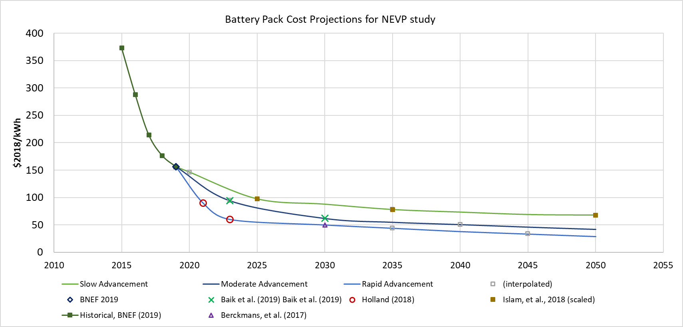

#### Battery vintaging factors

We calculate battery vintaging factor to account for batteries not lasting full vehicle lifetime. We assume batteries last 10 years and take the weighted average of battery packs needed over vehicle lifetime, using the retirement function to get share of vehicles still in use after certain timesteps.



For cars, buses, and light duty trucks (vehicles with 25-year max lifetime), the battery vintaging factor is 1.17, and for medium and heavy-duty trucks (vehicles with 40-year max lifetime) it is 1.35. For 2 and 3-wheelers, we assume no battery replacement is necessary.

#### **4W LDVs**

We update capital costs (purchase) to reflect our new battery cost curves. We extract the battery share of total purchase cost for BEV 100 compact cars by year from Autonomie data on vehicle component costs (Moawad et al. 2016) [9]. This data provides cost projections for vehicle components under low, average, and high non-battery technology advancement curves; we use the average case for this analysis. We then extract the percent difference between NREL’s battery cost assumptions and our new curves by year. For each size class, the new purchase cost is computed as:

New cost = old cost * (1 – ((battery cost % change from NREL) * (battery share of cost) * (battery vintaging factor))

#### **2-wheelers**

For 2-wheelers, new purchase costs were calculated largely the same way as for 4-wheel LDVs. However, we did not have data on battery share of cost from Autonomie (Moawad et al. 2016). We assume the battery is 37.5% of vehicle cost in 2020. This is based on assumption that 50% of the total cost of 2- and 3-wheelers are due to EV components and batteries constitute 75% of the EV component cost, which is generally true for compact cars from the Autonomie data. We assume the battery share of purchase cost decreases at the same rate as it does for compact cars, from Moawad et al. We update costs based on the new battery curves after scaling for cost parity in 2020 (described below) and creating Slow, Moderate, and Rapid curves using NREL’s battery costs and the same battery cost share as described above, because default 2- and 3-wheel costs from UCD study do not provide a range of costs.

#### **3-wheelers**

For 3-wheelers, we modify capital costs (total). New costs are calculated the same way as for 2-wheel and 4-wheel LDVs, but since the assumption is total capital costs rather than purchase, we add an extra factor for the purchase cost share of capital cost, so costs are calculated as:

New cost = old cost * (1 – ((battery cost % change from NREL) * (battery share of cost) * (purchase cost share of capital cost) * (battery vintaging factor))

Default taxes and fees for the Southeast Asia region are 35% of the price (Mishra et al. 2013), so 65% of the total is assumed to be purchase price. Like 2-wheelers, we assume BEV cost parity with ICEVs in 2020 (see below).

#### **Trucks**

There is only one cost variable for trucks, CAPEX and non-fuel OPEX ($/vkm), so we modify this by estimating the battery share of the levelized cost. Due to lack of data on the cost components of medium and heavy-duty truck classes, we use the battery share of purchase cost for BEV 100 pickup trucks from the Autonomie data (again using the average non-battery tech curve) for all truck classes. We estimate the purchase cost share of non-fuel levelized cost based on the component cost shares for compact cars using 2020 Moderate Advancement costs. Thus, the new costs are calculated as:

New cost = old cost * (1 – ((battery cost % change from NREL) * (battery share of cost) * (share of capital cost in LCOD) * (battery vintaging factor))

#### **Buses**

Like trucks, we modify CAPEX and non-fuel OPEX. We estimate the battery share of cost based on recent electric bus prices in China, the battery size of Proterra’s 440 kwh e-bus, and the 2019 battery pack price of $156/kWh[10]. Based on this, the share is 12.5% of cost in 2020, and we decrease it over time at same rate as the battery share of cost for BEV 100 pickup trucks from Moawad et al (2016). The capital cost share of non-fuel levelized cost comes from the EFS report. (figure 13 data). New costs are calculated as:

New cost = old cost * (1 – ((battery cost % change from NREL) * (battery share of cost) * (share of capital cost in LCOD) * (battery vintaging factor))

### Pakistan-specific transportation changes

We also make a number of updates to the assumptions for the Southeast Asia region, which contains Pakistan (Pakistan is not its own region in the vehicle assumptions). We add BEV 3-wheelers as a technology to reflect locally available vehicle types. Based on feedback from collaborators at SEP, we change 3-wheeler speed from 36 to 25 kilometers per hour and increase annual travel per vehicle from 8478 kilometers per year to 32,000 kilometers per year.

We update the cost assumptions for 2- and 3-wheelers in Southeast Asia. As NREL’s Electrification Futures Study (Jadun et al. 2017) does not report data for these vehicles, we rely on market data in Pakistan to determine current costs. A representative gasoline-powered motorcycle model in Pakistan costs about $800, about 59% of the cost assumption in the UCD database, so we scale all liquids 2-wheeler purchase costs by this value. Based on feedback from collaborators at SEP, electric 2-wheelers are already at levelized cost parity with conventional ICE 2-wheelers in Pakistan. Therefore, we back calculate purchase costs for BEVs in 2020 by class using ICEV cost assumptions and assuming equal levelized costs. After 2020, costs decrease according to the battery costs given in the three technology advancement pathways.

As BEV 3-wheelers do not exist as a technology in the current core GCAM and Pakistan-specific cost data is limited, we estimate BEV 3-wheel capital costs in 2020 using the ratio of liquids motorcycles to 3-wheelers in Southeast Asia in the original UCD database. This ratio (1.37) is then multiplied by the BEV motorcycle cost calculating purchase costs under levelized cost parity. After 2020, costs decrease according to the battery costs given in the three technology advancement pathways.

We also update BEV mini car costs and intensity to match the assumptions for India. This was the only car class and technology where assumptions did not match those in India, for unclear reasons, so we correct this discrepancy.

The infrastructure capital cost assumptions for BEVs come from Jadun et al. (2017), but these were based on costs in the U.S. A large portion of these costs were for labor associated with installation and upgrades to residential electrical systems. However, labor costs are much lower in Pakistan and many households have electrical service with a higher voltage compared to the U.S. We assume one charger required per vehicle, a typical residential power plug with 230V/10A and 100-35 km of driving daily. Based on market data in Pakistan, a level-2 charger costs $350-500, installation is $50-100, and residential electrical service upgrades cost $80-135. We assume an average charging infrastructure capital cost of $580 for 4-wheel LDVs. We remove charging costs entirely for 2-wheelers, as vehicle specifications indicate 2-wheeler batteries are sufficiently small that no additional charging infrastructure for residential use is required. We do assume 3-wheelers require the $580 charging infrastructure cost because of the high annual distance travelled per vehicle.

Collaborators at SEP collected information on typical maintenance costs for company and staff vehicles, as well as information from an informal survey of auto workshops, vehicle drivers, etc., around Islamabad. We use this to adjust our vehicle maintenance cost assumptions for LDVs. Actual average maintenance costs could be much lower than the values collected, however, as many owners tend to pay for maintenance only when unavoidable. We scale the values by 70% to represent more realistic maintenance.

In addition, market survey data provided by collaborators at ANL indicated that capital costs for light trucks and buses are significantly lower in Pakistan than the US. For the data available, vehicles in Pakistan were about 40% of the cost of comparable US vehicles. As GCAM truck costs are based on US data and do not vary by region, unlike LDVs, and bus cost assumptions are nearly identical between the US and Pakistan, we scale costs for buses, 0-2 ton trucks, and 2-5 ton trucks to represent this regional knock-down factor. Cost assumptions for buses and trucks are given as levelized non-fuel cost (per vehicle-kilometer traveled); we use cost assumptions for compact cars to calculate that purchase costs are about 76% of non-fuel levelized costs, and apply the 40% capital cost regional knockdown factor to that share of the levelized cost. This applies to all technologies within these classes. The cost difference appears to be less significant for heavy-duty trucks, so we leave these costs unchanged.

Bus costs were levelized by dividing by annual distance traveled of 51,708 km/year, while SEP assumes buses travel 72,000 km per year. For consistency, we scale bus costs for all technologies by 51708/72000 to implicitly change annual distance traveled. We also adjust BEV truck load factor assumptions for consistency across technology advancement scenarios. BEV truck load factors are set to 80% of liquids load factors in 2020 and linearly increase to be equal with liquids trucks in 2050. This change was made for Southeast Asia only.

The GCAM data system uses a default discount rate of 10% for consumer vehicle purchases. It should be noted that this value is only used to calculate a fixed charge rate, which converts capital costs to annualized costs as part of the levelized cost calculation. We change the discount rate to 15%, based on loan rates of 20-21% in Pakistan today[11] and average inflation of 5.5% over the past five years.[12]

# EV analysis

## Policy scenarios

The table below summarizes the EV policy scenarios. These are run in combination with Slow and Rapid Advancement cost pathways (see below), for a total of eight scenarios.

|  |  |  |  |  |
| --- | --- | --- | --- | --- |
| **Scenario No.** | **Scenario** | **Scenario Shorthand** | **Description** | **Applies to** |
| 1 | Reference | *NoPolicy_NoLoc* | No policies supporting EV adoption EV duties/taxes/registration based on assumption of no local manufacturing | Consumer vehicles (2, 3, 4-wheel LDVs) Buses Freight trucks |
| 2 | NEVP EV Duty Reductions, no EV localization | *NEVP_NoLoc* | National Electric Vehicle Policy (NEVP) recommendations for duty/tax/registration reductions for EVs, with no development of local manufacturing | Consumer vehicles (2, 3, 4-wheel LDVs) Buses Freight trucks |
| 3 | NEVP EV Duty Reductions, gradual EV localization | *NEVP_GradLoc* | National Electric Vehicle Policy (NEVP) recommendations for duty/tax/registration reductions for EVs, with gradual development of local manufacturing | Consumer vehicles (2, 3, 4-wheel LDVs) Buses Freight trucks |
| 4 | NEVP EV Duty Reductions, accelerated EV localization | *NEVP_AccelLoc* | National Electric Vehicle Policy (NEVP) recommendations for duty/tax/registration reductions for EVs, with accelerated development of local manufacturing | Consumer vehicles (2, 3, 4-wheel LDVs) Buses Freight trucks |

Pakistan’s vehicle taxes and duties are given as a percentage of the vehicle purchase price. For ICEVs, these are based Pakistan’s Automotive Development Policy 2016-2021, along with data on local manufacturing and imports of conventional liquids vehicles (Pakistan Business Council 2018). The final duties, taxes, and fees are assumed to be constant over time, and are shown in the table below:

**ICEVs:**

|  |  |
| --- | --- |
| **Vehicle Category** | **Final Duty, Tax & Fees (% of purchase price)** |
| Two-wheelers | **27.2%** |
| Three-wheelers | **29.6%** |
| Cars | **35.6%** |
| Buses | **35.1%** |

**EVS (proposed BEV tax/duty/fee reductions under National Electric Vehicle Policy):**

The NEVP contains numerous policy measures, differing by vehicle class, year, etc. This presents a challenge for representing the policy in GCAM. Below is a visual representation of the of the measures contained in the NEVP, by year and vehicle type:

|  | **Vehicle Category** | **Y1** | **Y2** | **Y3** | **Y4** | **Y5** | **Y6** | **Y7** | **Y8** | **Y9** | **Y10** | **Y11+** | **Comment** |
| --- | --- | --- | --- | --- | --- | --- | --- | --- | --- | --- | --- | --- | --- |
| **A.** | **NEVP Fig. 1, Page 12** | | | | | | | | | | | | This figure in the NEVP applies only to imports related to electric cars/LTVs (LUMS clarification) | |
| A.1 | Import of used EVs | 15% CD | |  |  |  |  |  |  |  |  |  |  |
| A.2 | Imported CKDs | 1% GST, nil registration fee | | | | | | |  |  |  |  | ‘CKD’ applies to whole vehicle (LUMS clarification) | |
| A.3a | Import of CBUs with EV specific parts | 1% CD, 1% GST | |  |  |  |  |  |  |  |  |  | ‘CBU’ refers to complete EV subassemblies (LUMS clarification) |
| A.3b | Import of CBUs with localized EV specific parts |  |  | 25% CD, 1% GST | | | | |  |  |  |  | ‘CBU’ refers to complete EV subassemblies containing parts that are otherwise being manufactured locally (LUMS clarification) |
| A.4 | Import of EV specific components and modules | 1% CD, 1% GST | | | | | | |  |  |  |  | Refers to EV-specific parts or components of subassemblies not being manufactured locally (LUMS clarification) | |
| **B.** | **Two- & three-wheelers** | | | | | | | | | | | |  | |
| B.1 | Imported EVs | 1% GST | | | | |  |  |  |  |  |  |  |
| B.2 | Locally manufactured EVs | < 1%GST | | | | | | |  |  |  |  |  | |
| B.3 | All two/three wheeler EVs | Nil registration feel and annual token | | | | | | | | | | |  | |
| B.4 | Import of EV specific parts and components (not manufactured locally) complying with intl. standards | 1% CD  1% GST | |  |  |  |  |  |  |  |  |  | Differs from A.4 |
| B.5 | Imported EVs | 25% CD | | | | | | | | | | | Not clear if three-wheelers covered under PCT Code 8703-8090 (‘Other vehicles, with only electric motor’) | |
| B.5 | Import of three wheeler CBUs with swappable batteries | 1% CD, 1% GST | | | | | | | | | | | For import of first 20,000 CBUs and related charging infrastructure by manufacturers who demonstrate setup for local manufacture of such units and battery charging infrastructure (no timeline specified) | |
| **C.** | **Cars/LTVs** | | | | | | | | | | | |  | |
| C.1 | Locally manufactured EVs | < 1%GST | | | | | | |  |  |  |  |  | |
| C.2 | Locally manufactured EVs | Nil registration fee and annual token | | | | | | | | | | |  | |
| C.3 | Imported EVs | Nil registration feel and annual token | | | | |  |  |  |  |  |  |  |
| C.4 | Import of EV specific parts and components (not manufactured locally) complying with intl. standards | 1% CD  1% GST | |  |  |  |  |  |  |  |  |  | Contradicts with A.4 |
| C.5 | Import of up to 3-year old used EVs | Allowed | |  |  |  |  |  |  |  |  |  | >3-year old imports not allowed under ADP 2016 for both ICEV & EV. 15% CD in A.1 not mentioned here |
| C.6 | Imported EVs | 25% CD | | | | | | | | | | | SRO issued subsequent to ADP 2016 | |
| C.7 | HEVs | 50%/25% | | | | | | | | | | | For engine sizes below/above 1800 cc | |
| C.8 | PHEVs | 50% | | | | | | | | | | |  | |
| **D.** | **Buses** | | | | | | | | | | | | | |
| D.1 | Imported/locally manufactured EVs | Import of first 200 electric buses at 1% CD, 1% GST  with the agreement that the other 800 buses will be manufactured in Pakistan (no timeline specified) | | | | | | | | | | | GoP will purchase 1,000 EVs and out-source to commercial operators  CD on additional EV imports not specified | |
| D.2 | Import of EV specific parts for locally manufactured EVs | 1% CD  1% GST | | | | | | | | | | | Applicability timeline not specified (to be defined in ADP 2021) | |
| D.3 | All EVs (buses) | Nil registration feel and annual token | | | | | | | | | | | Applicability timeline not specified (to be defined in ADP 2021) | |
| D.4 | Imported HEVs | 1% CD | | | | | | | | | | | Only HEVs mentioned in ADP 2016 | |
| **E.** | **Trucks** | | | | | | | | | | | | | |
| E.1 | Imported/locally manufactured EVs | Import of first 200 electric trucks at 1% CD, 1% GST  with the agreement that the other 800 trucks will be manufactured in Pakistan (no timeline specified) | | | | | | | | | | | GoP will purchase 1,000 EVs and out-source to commercial operators  CD on additional EV imports not specified | |
| E.2 | Import of EV specific parts for locally manufactured EVs | 1% CD  1% GST | | | | | | | | | | | Applicability timeline not specified (to be defined in ADP 2021) | |
| E.3 | All EVs (trucks) | Nil registration feel and annual token | | | | | | | | | | | Applicability timeline not specified (7 years?) | |
| E.4 | Imported EVs | 1% CD on HEVs | | | | | | | | | | | Only HEVs mentioned in ADP 2016 | |

|  |  |
| --- | --- |
|  | Draft National EV Policy (NEVP), 2019 [Text] |
|  | Draft National EV Policy (NEVP), 2019 [Fig. 1, Page 12] |
|  | Automotive Development Policy 2016-2021 (ADP 2016) |
|  | SRO 644(1)/2018 (May 24, 2018) |

**Note:** CKD: Completely knocked-down  
CBU: Complete built-up unit  
CD: Customs duty  
GST: General sales tax  
HEV: Hybrid electric vehicle  
PHEV: Plug-in hybrid electric vehicle

Source: Sustainable Energy for Pakistan (SEP) Project, 2020.

The NEVP proposes varying taxes, duties, and fees for imports and local production. For imports, duties differ depending whether materials and parts are EV-specific or not, and whether whole vehicle imports are completely built up (CBU) or complete knock down (CKD) units. To model the NEVP, we make assumptions about the level of EV production localization for each vehicle class. There are three localization scenarios: a base case with no EV localization, a gradual localization case, and an accelerated localization case. EV benefits under the NEVP are largely proposed to last 7 years, but as GCAM uses 5-year time steps, we model the NEVP over 10 years, from 2020 to 2030. Taxes, duties, and fees under the NEVP localization scenarios are given as a percentage of the purchase price.

|  |  |  |  |  |
| --- | --- | --- | --- | --- |
| **Base Case (no localization)** |  |  |  |  |
| **Vehicle Category** | **2020** | **2025** | **2030** | **2035** |
| Two-wheelers | 3% | 19% | 35% | 58% |
| Three-wheelers | 3% | 19% | 35% | 58% |
| Cars | 3% | 19% | 35% | 63% |
| Tractors | 2% | 19% | 36% | 60% |
| Buses | 2% | 19% | 36% | 60% |
| Trucks | 2% | 19% | 36% | 60% |
|  |  |  |  |  |
| **Gradual Localization** |  |  |  |  |
| **Vehicle Category** | **2020** | **2025** | **2030** | **2035** |
| Two-wheelers | 4% | 15% | 19% | 39% |
| Three-wheelers | 4% | 15% | 19% | 39% |
| Cars | 7% | 18% | 31% | 58% |
| Tractors | 2% | 17% | 30% | 52% |
| Buses | 2% | 18% | 32% | 55% |
| Trucks | 2% | 17% | 31% | 54% |
|  |  |  |  |  |
| **Accelerated Localization** | Final taxes, duties, and fees | | | |
| **Vehicle Category** | **2020** | **2025** | **2030** | **2035** |
| Two-wheelers | 9% | 13% | 10% | 28% |
| Three-wheelers | 9% | 13% | 10% | 28% |
| Cars | 8% | 13% | 14% | 37% |
| Tractors | 2% | 15% | 23% | 44% |
| Buses | 2% | 17% | 29% | 51% |
| Trucks | 2% | 16% | 25% | 47% |

These use the following localization assumptions:

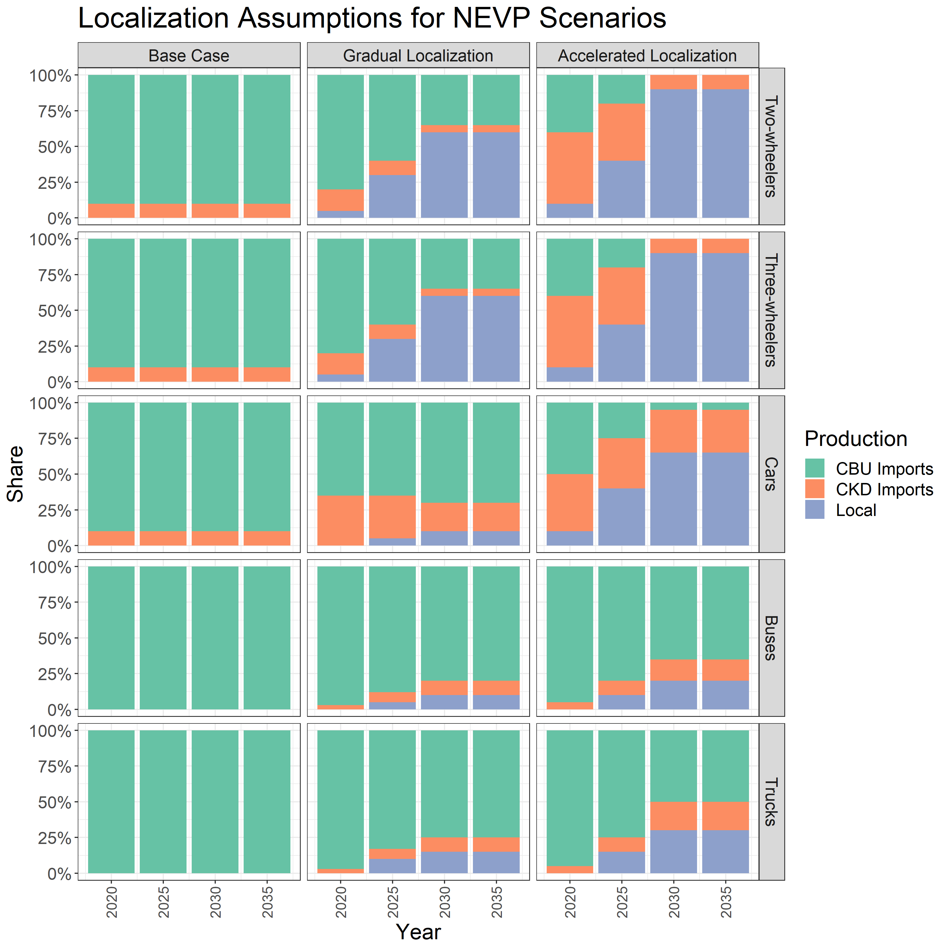

We also make the following assumptions about the share of EV-specific components by vehicle type (since custom duties are lowered under the NEVP for EV-specific parts):

|  |  |  |  |  |
| --- | --- | --- | --- | --- |
| **Vehicle Category** | **Allocation of EV Specific Material & Parts6** | | | |
| **2020** | **2025** | **2030** | **2045** |
| Two-wheelers | 30% | 25% | 21% | 19% |
| Three-wheelers | 30% | 25% | 21% | 19% |
| Cars | 30% | 25% | 21% | 19% |
| Tractors | 55% | 48% | 45% | 40% |
| Buses | 55% | 48% | 45% | 40% |
| Trucks | 55% | 48% | 45% | 40% |

Since vehicle classes have different types of capital cost assumptions, we implement the cost multipliers based on Pakistan’s taxes, duties, and fees in different ways. For 2-wheel and 4-wheel LDVs, we simply change capital costs (other), which represents sales tax and other costs not included in the manufacturer suggested retail price, to the given percentage of the purchase price. For 3-wheelers, taxes are included in capital costs (other), and for Southeast Asia average 35% of purchase price (Mishra et al. 2013). We adjust that 35% to the given taxes, duties, and fees multiplier for each scenario. For buses and trucks, the cost assumption is levelized CAPEX and non-fuel OPEX. We use the cost assumptions for multipurpose vehicles (under the Moderate Advancement scenario) to estimate the purchase cost share of levelized cost. This is about 54% for ICEVs and 58% for BEVs, because of the higher capital costs of BEVs. We use these shares to apply taxes, duties, and fees multipliers to truck and bus costs.

## Sensitivity analysis

Research has shown that consumers considering energy efficient technologies with higher capital but lower operating costs, including EVs, consistently discount the future savings they will receive (Lee and Lovellette 2011; Gallagher and Muehlegger 2011). As a sensitivity to highlight the importance of accurate perceptions of the cost advantages of EVs, for instance to demonstrate the effect of informational campaigns, we run a low and high case (slow advancement, NEVP gradual localization and rapid advancement, NEVP accelerated localization) with higher EV operating costs. We calculate these new operating costs for each LDV size class to represent a 30% discounting of future operational cost savings. Ideally this would be done by discounting both maintenance and fuel costs at a 30% rate, but as fuel costs are modeled endogenously, we use the fuel costs from the model output to calculate new maintenance costs that, when levelized, encapsulate higher discounting of all operating costs. We use this method to model consumer behavior because this effect was not fully captured in the share weights, as research shows discounting of future savings is a persistent effect even with mature technologies.

We also ran a sensitivity isolating the main policy measures included in the NEVP, to see which are most impactful for EV adoption. The measures isolated were the goods and services (GST) tax reductions, custom duty reductions on completely built up (CBU) imports, and custom duty reductions on complete knock down (CKD) imports. We calculate new tax, duty, and fee multipliers for purchase costs to show the effect of each policy lever, and run these on top of the high and low cases above.

1. <https://jgcri.github.io/gcam-doc/energy.html#transportation>
2. See appendix A.3 for details on updates to transportation assumptions.
3. See Appendix B.1 for details.
4. This is a function of the relative cost differences between EVs and ICEVs by size class in the default GCAM transport assumptions from Mishra et al. (2013), which carry over to the new cost assumptions because of the scaling method used (see appendix A.3.1).
5. Check the reasoning/sources behind these changes (and whether these should still be used as baseline assumptions in all scenarios).
6. <http://world-nuclear.org/getattachment/Our-Association/Publications/Online-Reports/World-Nuclear-Performance-Report-2018-Asia-Edition/world-nuclear-performance-report-asia-2018.pdf.aspx>
7. For cars, NREL’s cost data was pegged to the UCD size class of US midsize car. The ratios between vehicle costs in the original UCD database were used to scale the updated US midsize car costs to other size classes and regions. For trucks, a cost per ton was calculated and used to scale costs to all truck size classes (determined by the midpoint of the load factor). Truck costs do not vary by region.
8. |  |
   | --- |
   | Sources |
   |  |
   | * Baik, Y., Hensley, R., Hertzke, P., & Knupfer, S., (March 2019). Making electric vehicles profitable. Retrieved from: https://www.mckinsey.com/industries/automotive-and-assembly/our-insights/making-electric-vehicles-profitable |
   |  |
   | * Moawad, A., Kim, N., Neeraj, S., & Rousseau, A., (2016). Assessment of Vehicle Sizing, Energy Consumption, and Cost Through Large-Scale Simulation of Advanced Vehicle-Technologies (ANL/ESD-15/28). Retrieved from https://www.autonomie.net/pdfs/Report%20ANL%20ESD-1528%20-%20Assessment%20of%20Vehicle%20Sizing,%20Energy%20Consumption%20and%20Cost%20through%20Large%20Scale%20Simulation%20of%20Advanced%20Vehicle%20Technologies%20-%201603.pdf |

  
9. <https://www.autonomie.net/docs/ANL%20-%20BaSceFY17%20-%20Autonomie%20-%20Merge_Results_052317_181101.xlsx>
10. Based on market examples of a 395k-593k (“BYD K9” 2020) and $300-900k per bus in China (Poon 2019). Proterra is producing an e-bus with 440 kWh battery capacity (“Proterra: US Record for Electric Bus Battery Capacity - Sustainable Bus” 2019), with total cost ~$750k (Stromsta 2019).
11. <https://www.mawazna.com/loans/carLoanSteps/2?car_value=2980000&loan_amount=2533000&loan_period=7&model_year_value=&banks_included=1%2C10%2C11%2C15%2C19%2C20&city=Islamabad&model_year=2020&car_make=1&down_payment=15&loanTerm=7&source_of_income=1&income_value=25000&bank=1&bank=10&bank=11&bank=15&bank=19&bank=20>
12. <https://www.statista.com/statistics/383760/inflation-rate-in-pakistan/>